TEXTURE IN TUBES AND PLATES OF THE SUPERELASTIC/SHAPE-MEMORY ALLOY NITINOL

S. W. Robertson*, V. Imbeni**, E. Notkina***, H.-R. Wenk****, and R. O. Ritchie*

* Materials Sciences Division, Lawrence Berkeley National Laboratory, and Department of Materials Science and Engineering, University of California, Berkeley
** SRI International and The International Organization on Shape Memory and Superelastic Technologies
*** Technische Universität Hamburg-Harburg, Hamburg, Germany
**** Department of Geology and Geophysics, University of California, Berkeley

ABSTRACT
The superelastic/shape-memory material, Nitinol, a roughly equiatomic alloy of Ni and Ti, is rapidly becoming one of the most important metallic implant materials in the biomedical industry, in particular for the manufacture of endovascular stents. As such stents are invariably laser-machined from Nitinol tubes (or sheets rolled into tubes), it is important to fully understand the physical phenomena that may affect the mechanical behavior of this material. With tubing and sheet, one major issue is crystallographic texture, which can play a key role in influencing the mechanical properties of Nitinol. In this paper, we present a preliminary study on how geometry and heat treatment can affect the texture of Nitinol.

INTRODUCTION
The production of biomedical devices made from the shape-memory and superelastic alloy Nitinol, a roughly equiatomic alloy of Ni and Ti, employs numerous processing techniques, e.g. tube drawing, plate rolling, etc., and heat treatment processes in order to modify the microstructure, transformation temperatures, and mechanical properties. These procedures can lead to texturing (crystallographic alignment) of the material. There are a few, mainly qualitative, reports of textures in Nitinol sheets and plates¹⁻⁸ but no information for textures of tubes. Since Nitinol derives its unique nonlinear and anisotropic mechanical behavior from stress-induced martensitic transformations, where the resulting strains are affected by crystallographic orientation, it is clear that texture can have a marked influence on its mechanical properties. Indeed, Gall and Sehitoglu⁹ have concluded that texture, and consequently variants of martensite active during the transformation, are the source of the compression-tension asymmetry of Nitinol. Furthermore, Vaidyanathan et al. ¹⁰ have concluded that texturing can occur in Nitinol when martensite is stress-induced from austenite via such compression loading. Texture can have a critical effect in modeling the constitutive behavior of the alloy, as shown in Figure 1¹¹ where the assumption of the correct texture is shown to markedly influence the finite-element predictions of the equivalent stress-equivalent strain curve for Nitinol under combined tensile and torsional loading and unloading.

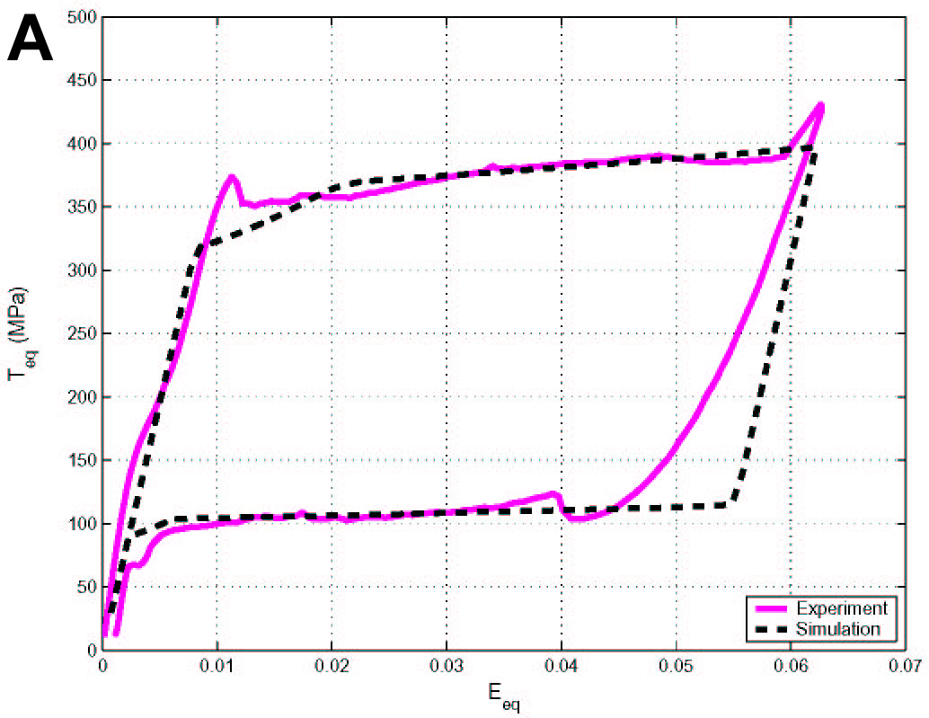 | 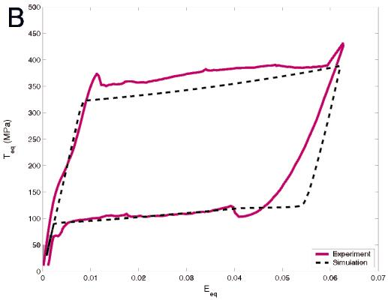

Figure 1: Finite element simulation curves of equivalent stress versus equivalent strain for Nitinol tubing under combined tension and torsion loading conditions a) assuming the correct texture of the tubes, and b) assuming incorrect texture.

It is the goal of this preliminary study to better understand how processing and heat treatment affect the texture in Nitinol, specifically by examining drawn tubes in comparison to rolled plate. The motivation for this comparison is to determine if such tubes could be simply modeled as plates rolled into a cylindrical form. This can be important where the flat geometry of plate specimens is preferred over a curved geometry for certain testing conditions, such as for microscopy studies which require a flat surface for resolution.

MATERIALS AND EXPERIMENTAL PROCEDURES
Nitinol tubing and plate (50.8 at.% Ni,) was received from Nitinol Devices & Components, Inc. and heat-treated, as described below, to modify the microstructure. The sample geometries (tube vs. plate) were chosen to determine if the processing (drawing vs. rolling) has a significant effect on the texture. The samples were heat treated to two different specifications:
- 485°C in air furnace for 5 minutes, followed by an ice-water quench (on both tube and plate).

- 850°C in vacuo furnace for 30 minutes followed by a slow cool (on plate only).

The tube dimensions were 4.6 mm outer diameter and 3.9 mm inner diameter; the plate sections were 15 mm square by 1 mm thick. The samples were too heavily deformed for SEM-EBSP texture measurements and therefore textures were measured with an x-ray pole figure goniometer. To provide large enough samples, the tube was sliced into sections (see Figure 2), the sections lined up side-by-side, cold-mounted in epoxy and ground flat. Figure 2 shows that two slice types were used, an offset cross-section (maximized geometry with minimum sample) and a pure radial cross-section (ideal axial alignment for easier pole figure interpretation). After combining the multiple tube slices into two samples, their sizes were approximately 10 mm square, the minimum sample size for quantitative texture analysis with an x-ray pole figure goniometer. All samples were mechanically ground and polished to a 0.05 μm finish to permit x-ray diffraction and establish consistency among the samples.
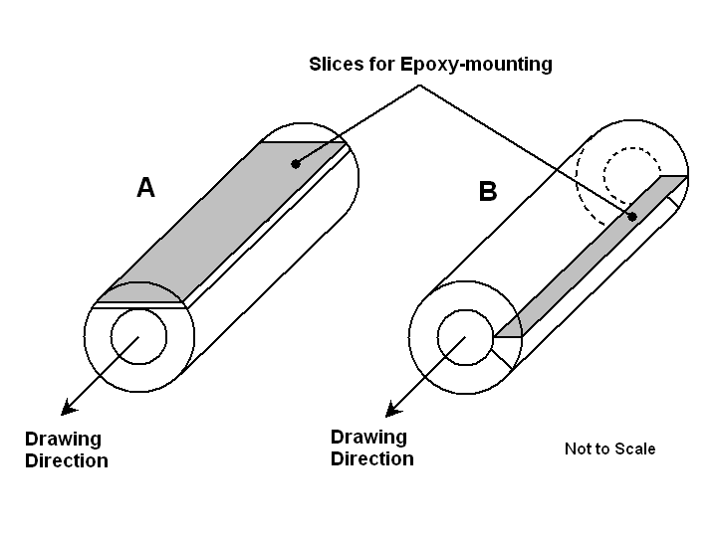

Figure 2: Diagram of slices from tube taken for texture measurements at a) offset cross-section, and b) pure radial cross-section

Both the tube and plate samples were fully austenitic at room temperature, i.e. the A_{f} < 25°C. Optical micrographs of the microstructure are shown in Figure 3. It should be noted that the imaged martensitic grains in the 485°C heat-treated samples are polishing artifacts; stresses from grinding and polishing cause transformation in the exposed grains which leaves residual surface relief on etching. Moreover, for the as-drawn conditions, the apparent grain sizes observed in Figures 3a and b also give a false impression about the actual grain size; the true grain size for the as-drawn or rolled tube and plate is on a sub-micron scale and can only be revealed by transmission electron microscopy¹². On the other hand, the optical micrograph in Figure 3c is representative of the grain size of the fully annealed plate, as the annealing has allowed significant recrystallization and grain growth.

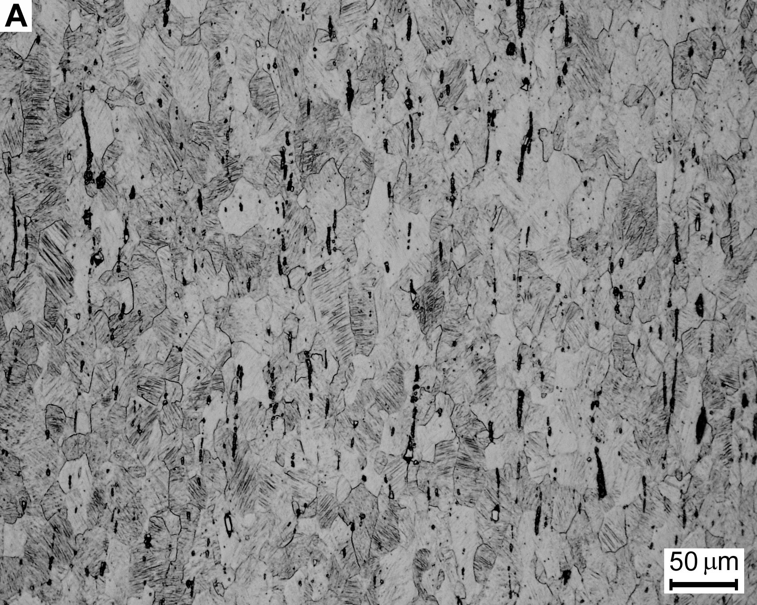 | 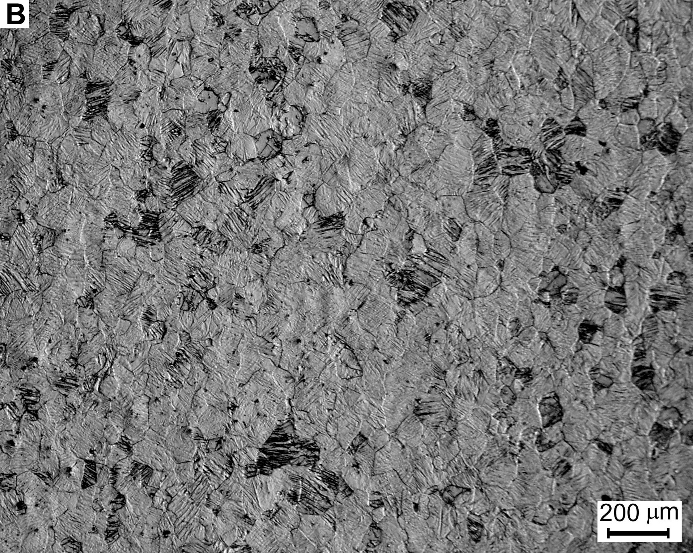 | 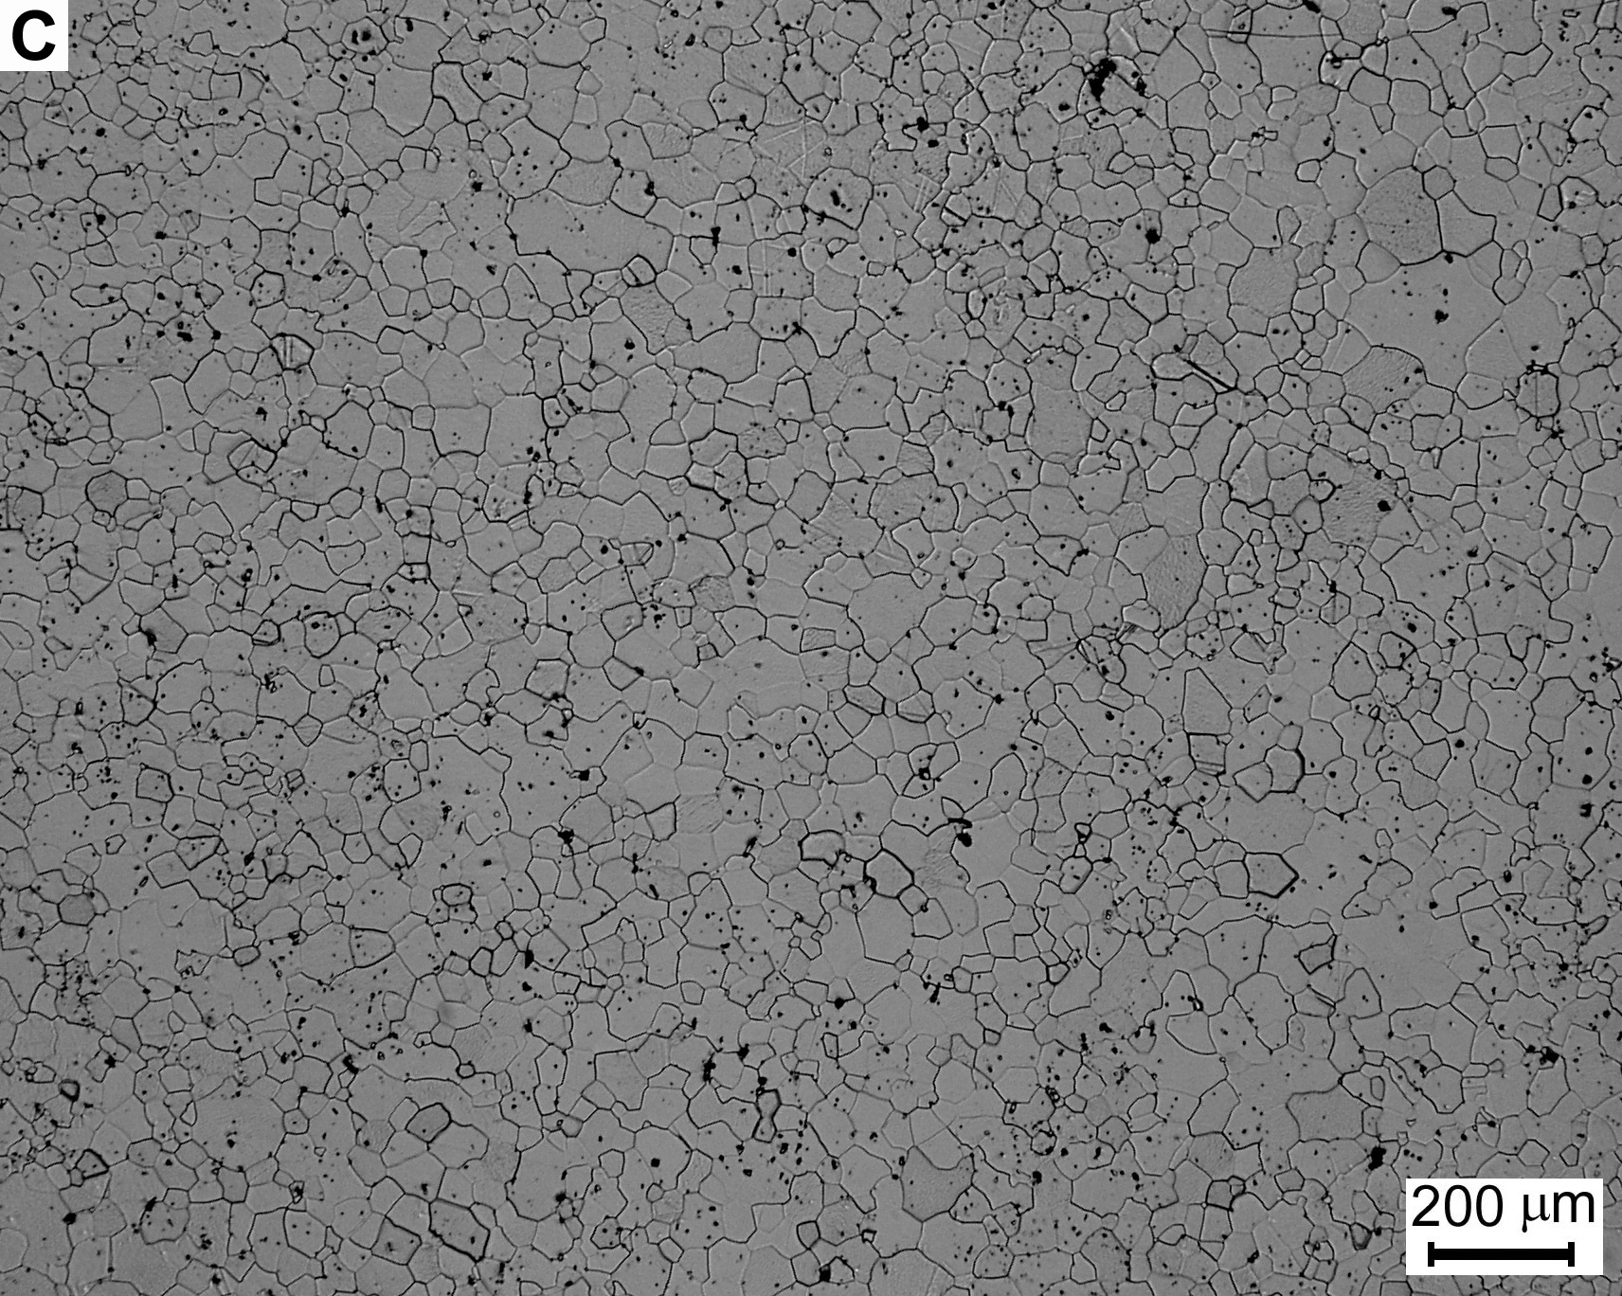

Figure 3: Optical micrographs of a) tube heat-treated at 485°C for 5 minutes; drawing direction is vertical, b) plate heat treated at 485°C for 5 minutes, and c) plate heat treated at 850°C for 30 minutes

The crystallographic texture of the Nitinol was determined from three incomplete measured pole figures (110, 200, and 211 poles, at Θ* values of 21.3°, 30.8°, and 38.9°, respectively) and using the WIMV* method in BEARTEX* to obtain the orientation distribution function (ODF)¹³. Pole figures were measured with a Huber X-ray pole figure goniometer with Cu-Kα radiation source at 40 kV and 14 mA, and a graphite monochromator. From the ODF, pole figures for 100, 110 and 111 poles were recalculated following smoothing and rotation operations and are presented in the following section, together with ODF sections.

RESULTS AND DISCUSSION

POLE FIGURES
The pole figures in Figure 4 reveal that the tube and plate heat-treated at 485°C show a significant texture. After corresponding rotations, pole figures derived from both sections of the 485°C heat-treated tube are similar (see Figures 4a and b). The main feature is a maximum in the 111 pole in the circumferential direction as indicated by the dark spots at 6 and 12 o’clock in Figures 4a and 4b, pole direction (p.d.) 111. In addition, texture minima occur in the 100 pole parallel to all three primary directions (drawing, circumferential, and radial) as indicated by white areas in Figures 4a and 4b, p.d. 100, at 3 and 9 o’clock, 6 and 12 o’clock, and center, respectively. The pole figure of the pure radial cross-sectioned tube, Figure 4b, shows a weak tendency in the 111 pole parallel to the radial direction.

The 485°C heat-treated plate displays a maximum in the 110 pole parallel to the rolling direction, as indicated by the highest intensity at 3 and 9 o’clock in Figure 4c, p.d. 110. Also, there is a 111 maximum parallel to the normal direction as shown by the dark spot concentration at the center of Figure 4c, p.d. 111. Furthermore, the 485ºC heat-treated plate has texture minima at the 100 and 111 poles parallel to the rolling direction as indicated by white areas at 3 and 9 o’clock in figures 4c, p.d. 100, and 4c, p.d. 111. Another minimum was observed at the 110 pole parallel to the normal (thickness) direction as indicated by the white spot in the center of Figure 4c, p.d. 110. The pole figures for this plate are consistent with body-centered cubic (BCC) rolling textures¹².

Pole figures of the 850°C heat-treated plate show stochastic variations due to poor grain statistics (see Figure 4d). A more regular pattern becomes apparent after additional smoothing (see Figure 4e). Scattering of the data in Figure 4d is attributed to recrystallization and grain growth experienced during the annealing. Figure 4e shows that the 850ºC heat-treated texture is generally the same as the plate heat-treated at 485°C, although the degree of texturing was much less in the higher temperature heat-treated condition, as indicated by the lower pole densities (the same contouring levels were used for all pole figures).

The only apparent similarity between Nitinol tube and plate texture is the minimum of the 100 pole in the rolling/drawing direction. There may also be a correlation between the tube’s weak, and plate’s strong, tendency to texture the 111 pole in the radial/normal direction. The significant differences in texture indicate that plate should not be used as a replacement for tubes when tests are geometry-limited. Moreover, plates that have been folded into a cylinder may not be assumed to have the same texture as tubes.
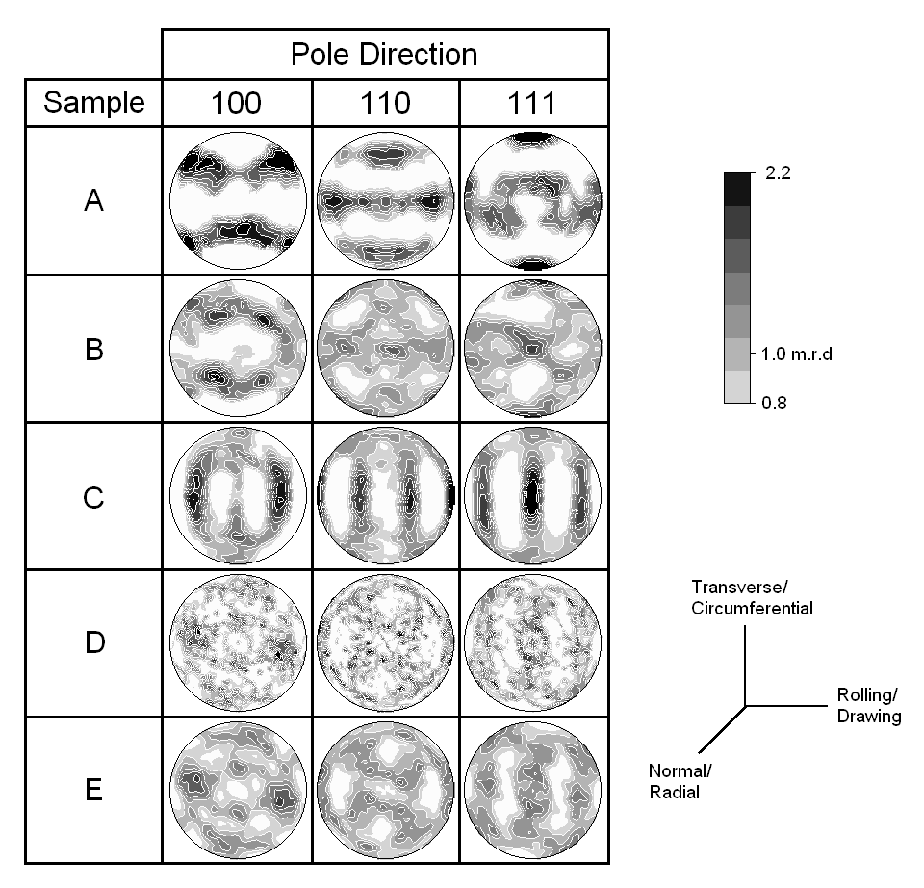
Figure 4: Pole figures showing texture in a) 485ºC H.T. Tube offset cross-section, b) 485ºC H.T. tube pure radial cross-section, c) 485ºC H.T. plate, d) 850ºC H.T. plate with one ODF smoothing operation (same as a-c), and e) 850ºC H.T. plate with three ODF smoothing operations

The observed plate textures in Figures 4c-e were similar to those previously determined by Monasevich et al.¹, Li et al.², and Inoue et al.⁴ on other Nitinol plate or sheet geometry. However, pole figures calculated by Kitamura et al.⁵ were different than those obtained in this study. Their work on much thinner Nitinol sheets (0.1 mm) revealed a texture maximum of the 110 pole normal to the sheet, whereas our data indicated a texture minimum at that location. That group also observed that, upon increased-temperature heat treatment (400ºC versus 600ºC, both for 60 minutes), maximum intensities of the 110 pole in the rolling direction diffuse toward the transverse direction creating offset local maxima. This trend was also observed in the pole figures collected in our experiment; notice how the maximum intensity spots at 3 and 9 o’clock in the 485ºC heat-treated plate (Figure 4c, p.d. 110), diffuse into four spots in the plate heat-treated at 850ºC (Figure 4e, p.d. 110).

Sample Orientation Distributions (SODs)
In order to obtain further information on texture components, the ODF was analyzed in sample orientation distribution (SOD) sections, displaying sample orientations in terms of crystal coordinates ϕ₁ and Φ (Bunge nomenclature is used). Figure 5 shows four SOD sections at ϕ₁ values of 0, 15, 30 and 45 degrees for the 485ºC heat-treated tube and plate. The plate shows the typical features of a BCC rolling texture with α fiber in the ϕ₁=0º section and a γ fiber extending parallel to ϕ₁¹⁴.

In the tube sample, the α fiber is absent and the γ fiber is only weakly developed. The most pronounced orientation concentration, labeled as point A in the figure, is in the ϕ₁=45º section at Φ =90º and ϕ₁=45º. Interpretations of the details contained in each SOD section is beyond the scope of this preliminary investigation, but will be conducted in future studies to completely characterize the tube texture and understand its development.
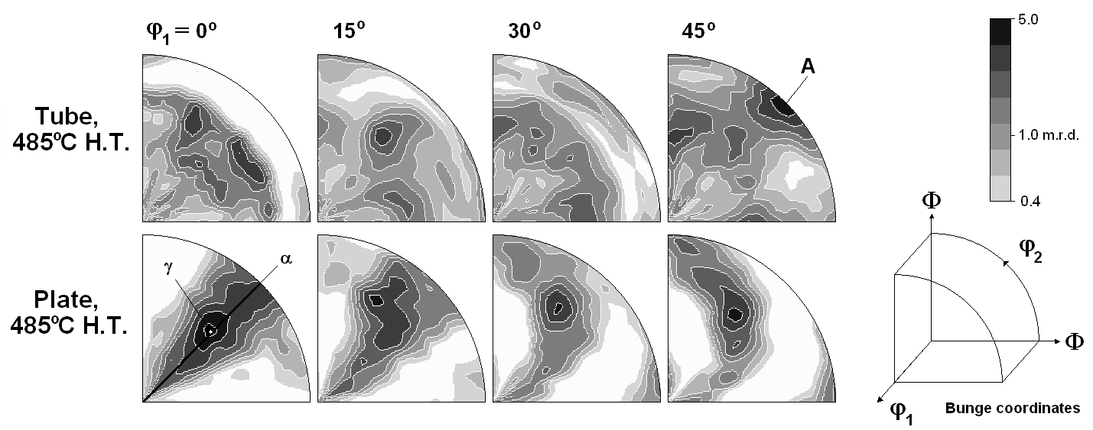
Figure 5: Selected Sample Orientation Distributions (SODs) for 485ºC heat-treaded tube (pure radial cross-section) and plate in polar coordinates; point A is the most pronounced texture component for the tube. The α fiber, and γ fiber for the plate are indicated.

The results presented in this report are based upon pole figure collection of one sample of each selected geometry and heat treatment. Future experiments are needed to confirm the findings presented here and to further investigate the influence of deformation conditions on texture and also on texture changes during the phase transformation.

PRELIMINARY OBSERVATIONS
Room-temperature fully austenitic Nitinol tubes and plates have been shown to be highly susceptible to crystallographic texturing following mechanical processing (drawing or rolling) and heat treatment. Specific conclusions include:

- The tubes were found to be strongly textured in the 111 pole, along the circumferential direction. They have a weak tendency to texture the 111 pole in the radial direction. Also, the tubes have texture minima of the 100 pole in the circumferential, drawing, and radial directions.

- The plates correspondingly were found to be textured with α and γ fibers, both common in BCC rolling textures. α fibers produce 110 poles parallel to the rolling/drawing direction, whereas the γ fiber is characterized by the 111 pole parallel to the normal direction (i.e. plate thickness). Texture minima occur in both the 100 and 111 poles parallel to the drawing direction, and in the 110 pole parallel to the normal direction.

- Drawn tubes and rolled plates were observed to have few similarities in texture. We conclude therefore that plates should not be used as a substitute for tubes when testing is geometry-limited. In addition, plates that have been rolled into a cylinder cannot be assumed to have the same texture as tubes.

- Some degree of remnant texture was found in Nitinol plate, even after a full anneal at 850°C for 30 minutes. This texture is similar to that of plate heat-treated at 485ºC for 5 minutes.

ACKNOWLEDGMENTS
This work was supported in part by a gift from Nitinol Devices and Components (NDC), Inc., Fremont, California, and in part by Grant no. CMS-980006 from the National Science Foundation, both to the University of California at Berkeley. Thanks are due to Drs. Tom Duerig and Alan Pelton of NDC for supplying the Nitinol tubing and for many helpful discussions.

REFERENCES
- L. A. Monasevich, Yu. I. Paskal’, V. E. Prib, G. D. Timonin, and D. B. Chernov, Effect of Texture on the Shape Memory Effect in Titanium Nickelide, Met. Sci. Heat Treat., Vol. 21 (9), 1979, pp. 735-737.
- D. Y. Li, X. F. Wu and T. Ko, The Texture of Ti-51.5 at.% Ni Rolling Plate and its Effect on the All-Round Shape Memory Effect, Acta Metall. Mater., Vol. 38, 1990, pp. 19-24.
- J. H. Mulder, P. E. Thoma and J. Beyer, Anisotropy of the Shape Memory Effect in Tension of Cold-rolled 50.8 Ti 49.2 Ni (at. %) Sheet, Z. Metallkd., Vol. 84, 1993, pp. 501-508.
- H. Inoue, N. Miwa and N. Inakazu, Texture and Shape Memory Strain in TiNi Alloy Sheets, Acta Mater., Vol. 44, 1996, pp. 4825-4834.
- K. Kitamura, S. Miyazaki, H. Iwai, and M. Kohl, Effect of Heat-Treatment on the Texture in Rolled Ti-Ni Thin Plates, SMST-97, pp. 47-52.
- Y. C. Shu and K. Bhattacharya, The Influence of Texture on the Shape-Memory Effect in Polycrystals, Acta Mater., Vol. 46, 1998, pp. 5457-5473.
- E. Hornbogen, G. Bruckner and G. Gottstein, Microstructure and Texture of Ausformed NiTi, Z. Metallkd., Vol. 93, 2002, pp. 3-6.
- H. Sitepu, W. Schmahl, B. Von Dreele, Use of the Generalized Spherical-Harmonic Model for Describing Texture in Polycrystalline NiTi Shape Memory Alloys with Time-of-Flight Neutron Diffraction Data, Appl. Phys. A, Vol. 74, 2002, pp. S1676-S1678.
- K. Gall and H. Sehitoglu, The Role of Texture in Tension-Compression Asymmetry in Polycrystalline NiTi, Int. J. Plasticity, vol. 15, 1999, pp. 69-92.
- R. Vaidyanathan, M. A. M. Bourke and D. C. Dunand, Texture, Strain, and Phase-Fraction Measurements during Mechanical Cycling in Superelastic NiTi, Metall. Mater. Trans. A, vol. 32A, 2001, pp. 777-786.
- Y. Jung and P. Papadopoulos, Constitutive Modeling and Numerical Simulation of Multivariant Phase Transformation in Shape Memory Alloys, unpublished work, University of California, Berkeley, 2003.
- Z. Q. Li and Q. P. Sun, The Initiation and Growth of Macroscopic Martensite Band in Nano-Grained NiTi Microtube Under Tension, Int. J. Plasticity, vol. 18, 2002, pp. 1481-98.
- H.-R. Wenk, S. Matthies, J. Donovan and D. Chateigner, BEARTEX, a Windows-based Program System for Quantitative Texture Analysis, J. Appl. Cryst., Vol. 31, pp. 262-269.
- U. F. Kocks, C. N. Tome and H.-R. Wenk, Texture and Anisotropy, Cambridge University Press, 1998, pp. 195-196.

* Θ is equal to half of the angle between the x-ray source and detector; WIMV calculates orientation distributions from pole figures; BEARTEX is a software package for quantitative texture analysis.

